**Object Oriented Programming**

**Lab Report**

**Lab14**



|  |  |
| --- | --- |
| Group Members Name & Reg #: | **Muhammad Haris Irfan**  **(FA18-BCE-090)** |
|  |  |
| Class | Object Oriented Programming CSC241 (**BCE-4B**) |
| Instructor’s Name | Maam Amber Madeeha Zeb |

**In Lab Tasks**

5.1 Question 1:



**Solution:**

The Above-mentioned codes were practiced.

____________________________

5.2 Question 2:



**Solution:**The code is given below,

1 #include <iostream>

2

3 **using namespace std**;

4

5 **class** absolute

6 {

7 **private**:

8

9 **int** t=0;

10

11 **public**:

12

13

14

15 **void** getvalue()

16 {

17 **try**

18 {

19 **cout**<<"Enter value?"<<**endl**;

20 **cin**>>t;

21

22 **if**(t<0)

23 **throw** (t);

24

25 }

26

27 catch(int )

28 {

29 cout<<"Error! The class only works for absolute values, cannot enter Negative value!"<<endl;

30 }

31 }

32

33 };

34

35 int main()

36 {

37

38

39 absolute a1;

40 a1.getvalue();

41

42

43 return 0;

44 }

**Console Output is shown below.**

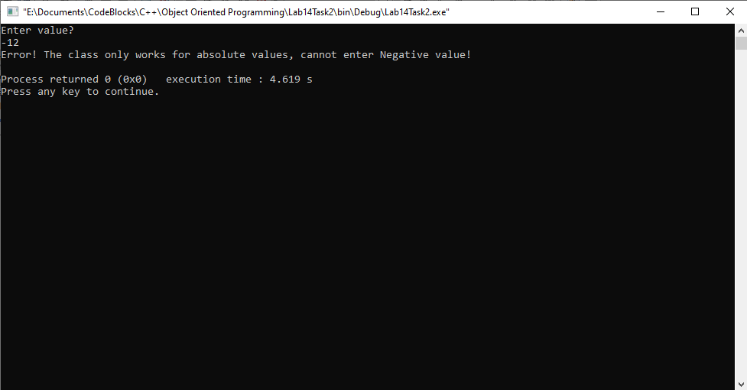

____________________________

5.3 Question 3:



**Solution:**The code is given below,

1 #include <iostream>

2 #include<conio.h>

3 **using namespace std**;

4

5

6 **class** exceptionn

7 {

8 **private**:

9 **int** t=1;

10 **public**:

11

12 **void** func()

13 {

14 **try**

15 {

16 **if**(t!=0)

17 **throw** t;

18 }

19

20 **catch**(**int**)

21 {

22 **cout**<<"Error!"<<**endl**;

23 **throw** t;

24 }

25

26 }

27

28 };

29 **int** main()

30 {

31

32 exceptionn e1;

33 **try**

34 {

35 e1.func();

36 }

37

38 **catch**(**int**)

39 {

40 **cout**<<**endl**<<"Value should not be less then 0!"<<**endl**;

41 }

42

43 **return** 0;

44 }

**Console Output is shown below.**

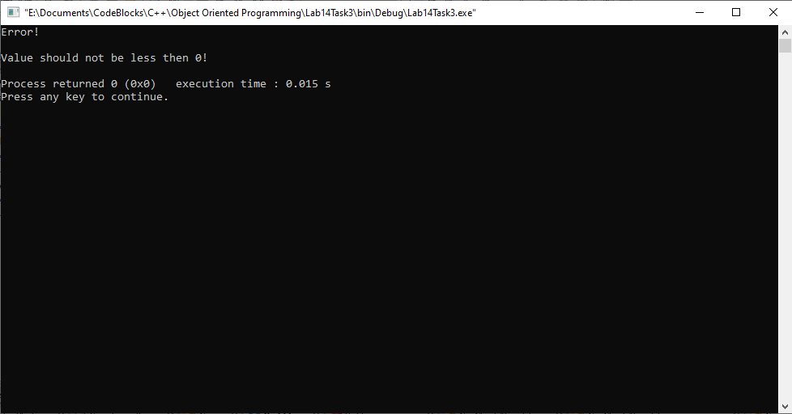

____________________________

POST LAB

6.1 Question 4:



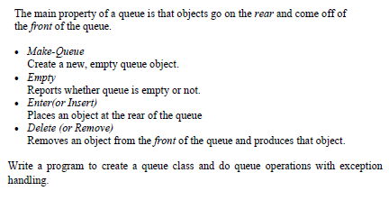

Solution:

I am attaching my code below,

1 #include <iostream>

2

3 **using namespace std**;

4

5

6 **class** que

7 {

8 **private**:

9 **int** que[5];

10 **int** index=5;

11 **int** frontqu=-1;

12 **int** rear=-1;

13 **public**:

14

15 **void** chckempty()

16 {

17 **try**

18 {

19

20

21 **if**(frontqu==-1)

22 **throw** frontqu;

23 **else**

24 **cout**<<"Queue is not Empty"<<**endl**;

25

26 }

27

28 **catch** (**int**)

29 {

30 **cout**<<"Queue is Empty"<<**endl**<<**endl**;

31 }

32

33 }

34

35 **void** enqueue()

36 {

37

38 **int** val;

39 **try**

40 {

41

42 **if** (rear == index - 1)

43 **throw** rear;

44 **else**

45 {

46 **if** (frontqu == - 1)

47 frontqu = 0;

48 **cout**<<"Insert the element in queue : "<<**endl**;

49 **cin**>>val;

50 **cout**<<"Element Inserted!: "<<**endl**;

51 rear++;

52 que[rear] = val;

53 }

54

55 }

56

57 **catch** (**int**)

58 {

59 **cout**<<**endl**<<"Queue is Full"<<**endl**<<**endl**;

60 }

61

62 }

63

64

65 **void** dequeue()

66 {

67

68 **try**{

69

70 **if** (frontqu == - 1 || frontqu > rear)

71 {

72

73 **throw**(frontqu) ;

74 }

75

76

77 **else** {

78 **cout**<<"Element deleted from queue is : "<< que[frontqu] <<**endl**;

79 frontqu++;;

80 }

81 }

82 **catch**(**int**)

83 {

84

85 **cout**<<**endl**<<"Queue Underflow! The Queue is Empty! "<<**endl**;

86

87 }

88 }

89

90 };

91

92 **int** main()

93 {

94 que q1;

95

96 q1.chckempty();

97

98 q1.enqueue();

99 q1.enqueue();

100 q1.enqueue();

101 q1.enqueue();

102 q1.enqueue();

103 q1.enqueue();

104

105 q1.dequeue();

106 q1.dequeue();

107 q1.dequeue();

108 q1.dequeue();

109 q1.dequeue();

110 q1.dequeue();

111

112

113

114

115

116 **return** 0;

117 }

**The result for this program is shown below,**

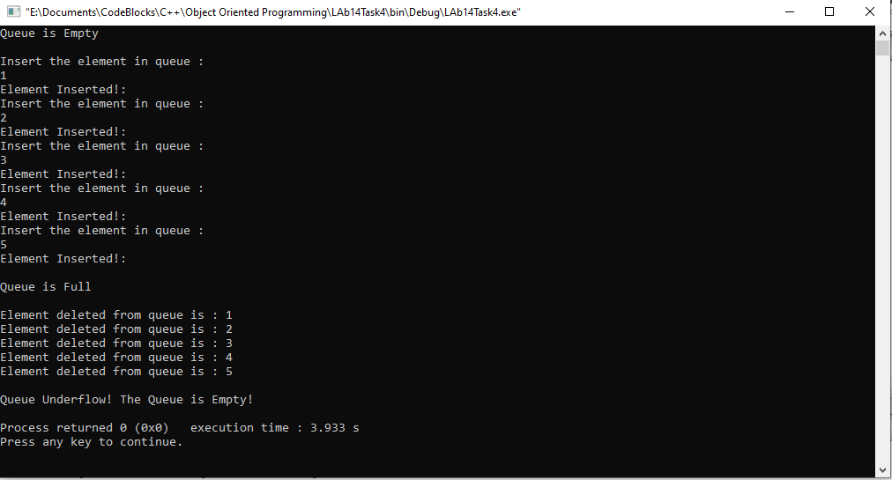

______THE END________

_______________